Assignment 3
2124UCSF1090
write a program using shell programming to implement an address book with options given below: a) create address book.

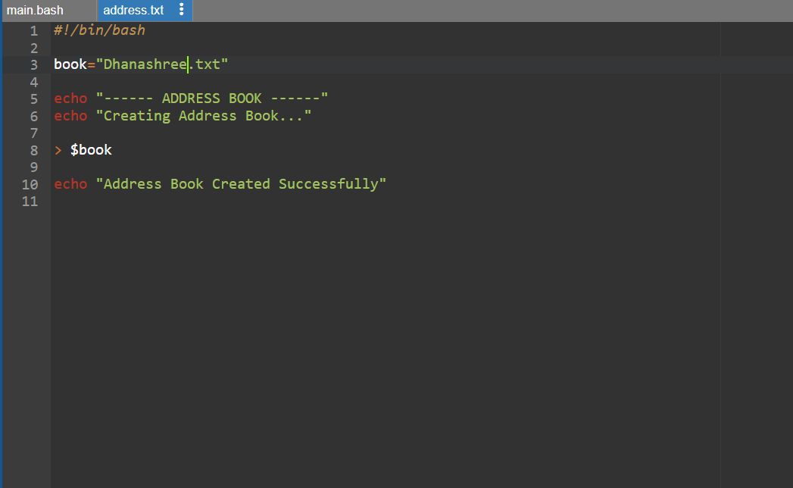

Output
